Exercise 31: Apple Fields and Properties

Although this exercise isn't worth any points, it gives you valuable programming experience. You're almost definitely going to have to complete the exercises to succeed in the course.

**The Problem**

Implement the fields and properties for the Apple class from the previous exercise. Here’s the class diagram as a reminder:

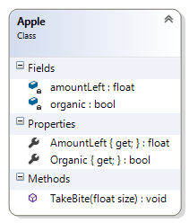

You won't be able to test your code until you implement the constructor in the next exercise.